# **Power BI Project Documentation**

## **1. Project Overview**

### **1.1 Project Title**

MAVENTECH SALES DASHBOARD

### **1.2 Objective**

To develop an interactive sales dashboard that will help sales manager to track their teams quarterly performance.

### **1.3 Scope**

The dataset spans from October 2016 to December 2017 and is exported from MavenTech’s CRM system.MavenTech , a company that specializes in selling computer hardware to large businesses.They’ve been using a new CRM system to track their sales opportunities. The following tables were used:

* **Sales Pipeline Table (Fact Table)**Contains 8,800 rows and 8 fields, including opportunity ID, sales agent, product, account, deal stage, engagement dates, closure dates, and revenue from deals.
* **Accounts Table (Dimension Table)**Contains 85 rows and 7 fields, detailing company information, such as industry sector, revenue, number of employees, and parent company relationships.
* **Product Table (Dimension Table)**Contains 7 rows and 3 fields, listing products, product series, and suggested retail prices.
* **Sales Teams Table (Dimension Table)**Contains 35 rows and 3 fields, detailing information on sales agents, managers, and regional offices.
* **Key Metrics:**

The total revenue generated by each salesperson.

The total count of products sold by each salesperson.

* **Visualizations Included:**
* Win vs. Loss Analysis: Won and lost deals over quarters with win rate trend.
* Team Performance Metrics: Individual sales contributions by agents and managers, highlighting top performers.
* Product-Wise Revenue: Revenue distribution across different products.
* Sector -wise Revenue: Revenue distribution
* Top 5 companies
* Bottom 5 companies.
* A stacked barchart to visualize revenue of sales agent under each sales manager
* Average Deal Closure Time: Insights into sales cycle efficiency and time taken to close deals.
* Variance Analysis: Comparison of sales prices with recommended retail prices to track deviations.
* Detailed Sales Report: Tabular breakdown of sales agents, product sales, accounts, and average deal closure times

### **1.4 Timeline**

|  |  |  |
| --- | --- | --- |
| **Phase** | **Description** | **Estimated Duration** |
| Data Collection | Gathering relevant datasets | 1 days |
| Data Cleaning | Handling missing values, removing duplicates | 1/2 days |
| Data Modeling | Defining relationships, creating measures | 1/2 days |
| Visualization | Designing dashboard and visual elements | 3 days |
| Final Review | Testing and refining dashboard | 2 days |

## **2. Data Collection & Preparation**

### **2.1 Data Sources**

The datasets are provided in a CSV file.

### **2.2 Data Cleaning & Transformation**

**Removing Duplicates:**

* Removed complete duplicates to ensure data consistency and prevent double counting.

**Dropping Irrelevant Columns:**

* Removed the subsidiary_location column in the accounts table since it contained 85% null values, making it unfit for meaningful analysis.

**Data Type Changes:**

* Changed the data types of engage_date and close_date columns to Date format to enable proper date-based calculations and visualizations.

### **2.3 Data Model**

* The model follows a **star schema**, where the Sales Pipeline fact table is at the center, and dimension tables radiate around it, forming direct one-to-many relationships.
* Each dimension table has a primary key, which is referenced as a foreign key in the fact table.

## **Dashboard Development**

## **Mockup Designs**

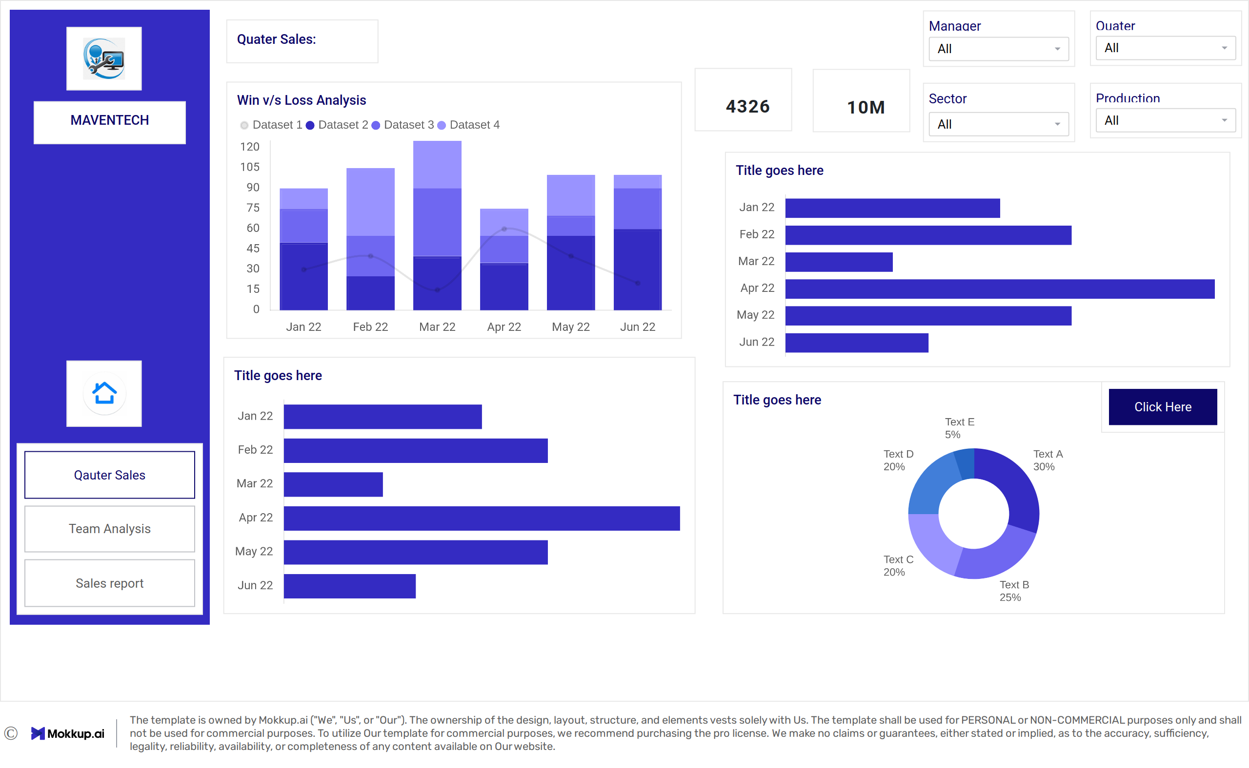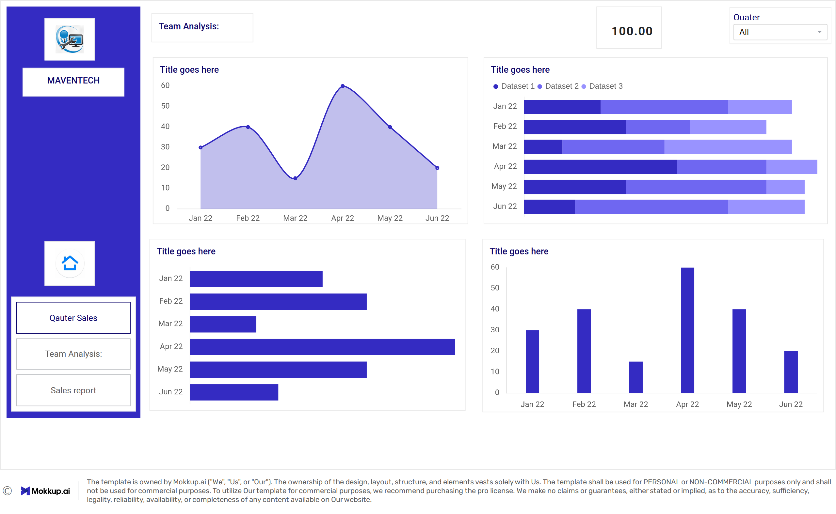

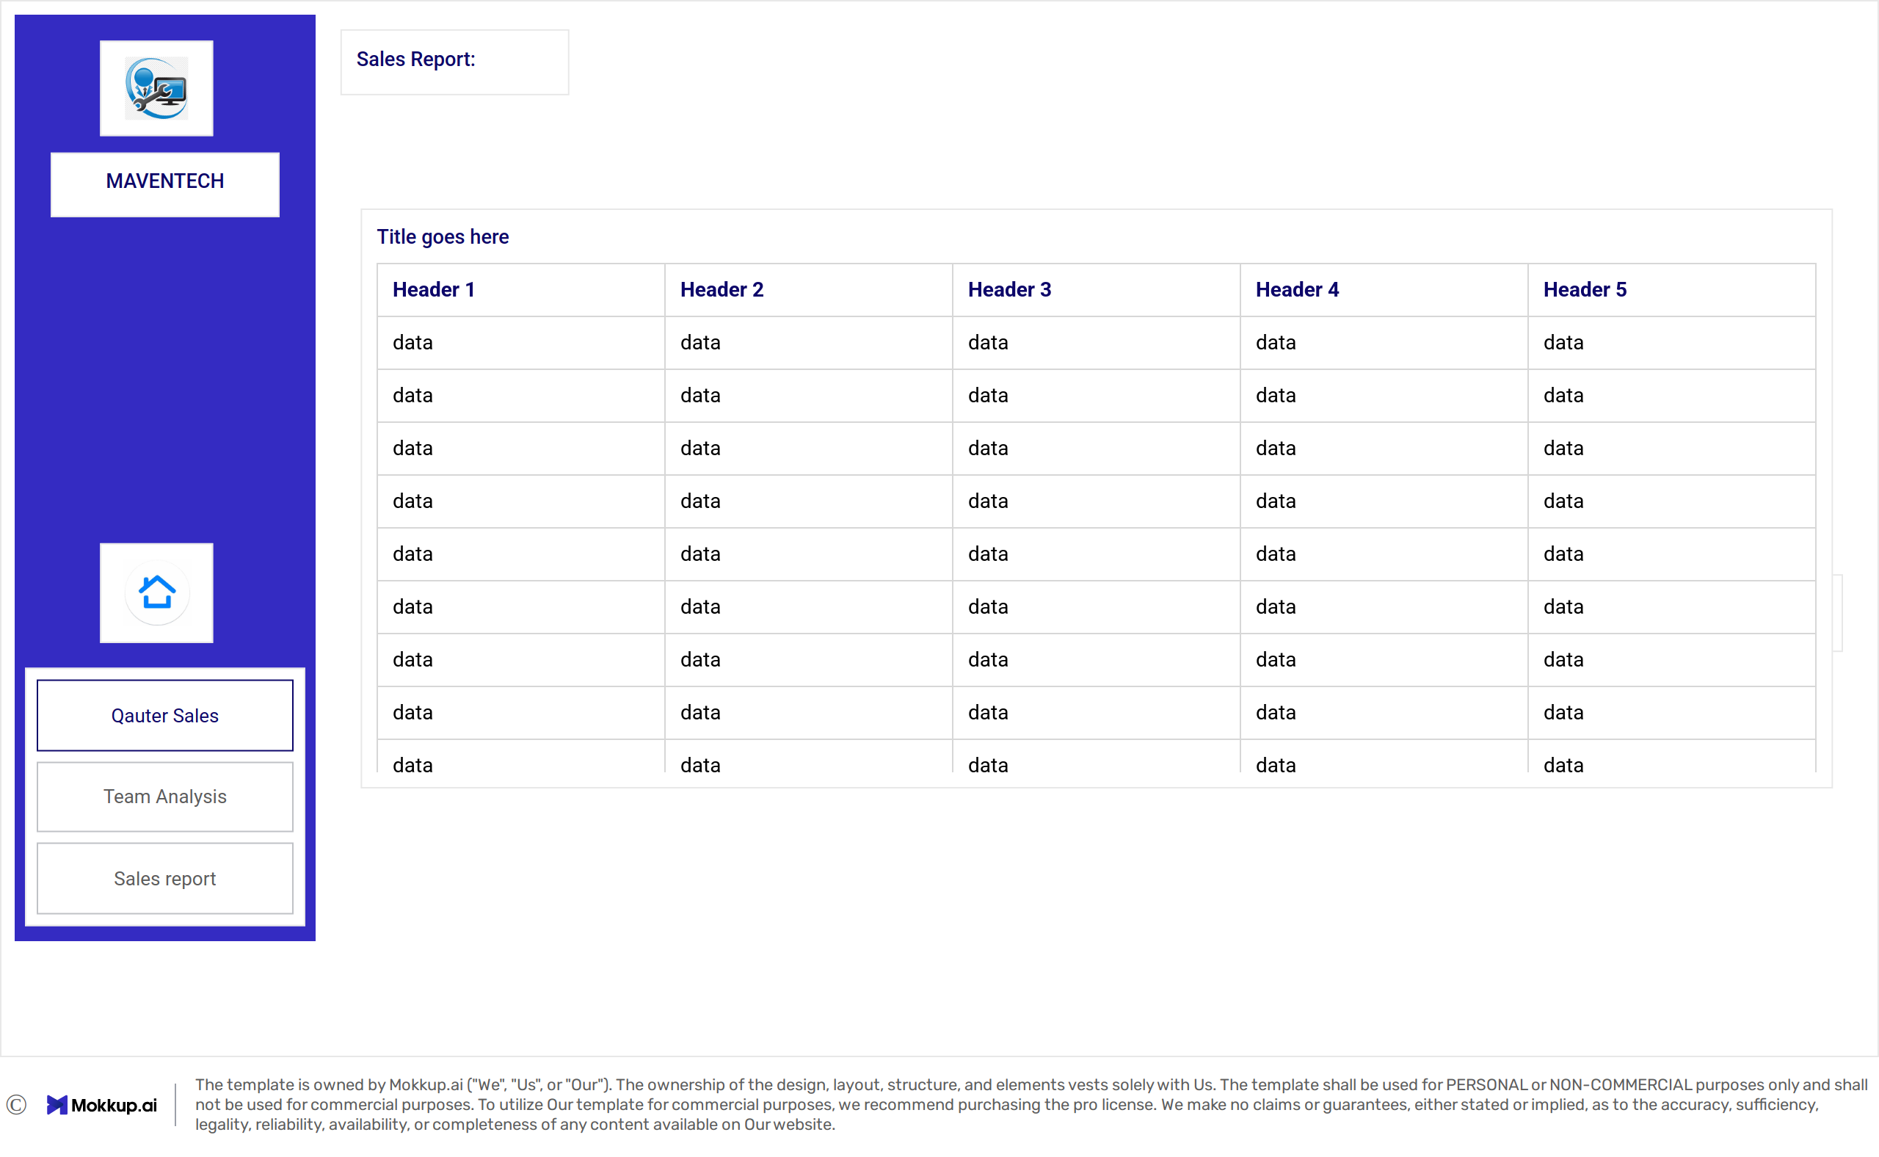

### **3.2 Key Visualizations**

**Card Visuals:**

* + Total Product Sales
  + Total Sales

**Stacked Bar Chart:**

* + Win vs. Loss Analysis

**Horizontal Bar Charts:**

* + Top 5 Salespersons with the Highest Total Sales
  + Top 5 Companies by Revenue
  + Bottom 5 Companies by Revenue
  + Average Deal Closure Time by Sales Manager

**Donut Charts:**

* + Revenue Distribution Across Different Products
  + Overall Revenue Distribution

**Stacked Bar Chart:**

* + Revenue of Sales Agents under Each Sales Manager

**Column Chart:**

* + Variance From recommented retail price

**Table:**

* + Detailed Sales Report

**Interactive Features:**

* **Toggle Button:** Used to switch between different views & chart types for enhanced user experience.
* **Drill-Through:** Enabled for detailed data exploration from summary visuals.
* **Tooltips:** Incorporated to display additional information when hovering over data points.

### **3.3 Measures and Calculations**

**Calculated Columns:**

· **Quarter Column:** Extracted from the engagement or closure dates to group sales data by quarters.

· **Days to Close Column:** Calculated as the difference between the Close Date and Engage Date to measure deal closure time.

**DAX Measures:**

· **Total Sales:** Sum of the sales amount for all deals.

· **Average Days to Close:** Average duration to close a deal.

· **Total Deals:** Count of all deals in the sales pipeline.

· **Won Deals:** Count of successfully closed deals.

· **Lost Deals:** Count of unsuccessful deals.

· **Win Rate:** Calculated as (Won Deals / Total Deals) * 100.

· **Average Won Deals:** Average sales amount for won deals.

· **Price Variance:** Difference between the highest and lowest product prices for deals.

· **Price Variance Percentage:** (Price Variance / sum(close_value)) * 100.

· **Row Sales:** For giving a color scheme to entire rows

· **Total Sales Contribution:** Percentage of individual sales contribution to total sales.

· **Total Product Sales:** Sum of sales grouped by product.

· **Total Sales for All Teams:** Combined sales amount generated by all sales teams.

### **3.4 Filters and Slicers**

**Date Filters:**

Slicers for selecting specific quarters were provided using the calculated Quarter column.

**Category Filters:**

· Product Filter: Allows users to focus on sales performance for specific products.

· Sector Filter: Enables segmentation of sales data based on different industry sectors.

· Manager Filter: Helps drill down into the sales performance of specific sales managers.

**4. Insights & Findings**

· Q2 and Q3 of 2017 had the highest number of won deals, while Q1 had the lowest.

· The win rate in Q4 slightly declined compared to earlier quarters.

· Darcel Schlecht led the sales agents with total sales exceeding $1.15M.

· Other top agents, including Vicki Laflamme and Kary Hendrixson, followed at approximately $0.45M.

· GTX Pro generated the highest revenue ($4M).

· Other significant contributors were GTX Plus Pro ($3M) and MG Advanced ($2M).

· Melvin Marxen handled the highest number of deals, followed by Summer Sewald and Dustin Brinkmann.

· The variance from the recommended retail price was highest for Dustin Brinkmann, indicating potential price negotiation issues.

* Dustin Brinkmann had the longest average days to close deals, suggesting room for improvement in closing efficiency.
* The sales report highlights detailed insights into deals per account and their corresponding revenue.

**5. Challenges & Limitations**

I encountered challenges while developing complex DAX measures.

## **6. Future Enhancements**

To improve the project, I plan to resolve the challenges faced while developing DAX measures as well as integrate additional data sources, refine visualizations, and automate data refresh for real-time insights.

## **7. Conclusion**

This Power BI project provides sales managers with an interactive dashboard to track key performance indicators such as total product sales, total revenue, deal win rates, and sales contributions by agents and managers. By visualizing data trends, win-loss analysis, and variance insights, it enables data-driven decision-making and performance optimization. The dashboard addresses the problem statement by offering a comprehensive tool that enhances sales tracking, identifies top and bottom performers, and highlights areas for improvement, ultimately driving strategic sales growth.

## **8. Appendix (If Required)**

I referenced Maven Analytics Challenges for inspiration and guidance during this project.